Difference between Centralized Database and Distributed Database

Databases are widely used for efficient storage, search, and other operations with data in the process of data management. Listening to the experience of using databases, two major categories are Centralized Databases and Distributed Databases. It is crucial to grasp the distinctions between these two types since every one of them possesses certain benefits and drawbacks as well as applicable to different circumstances. This article will try to explain the basic differences between a Centralized database and a Distributed database so that you can decide which one is most appropriate for you.

What is a Centralized Database?

A Centralized Database is a type of database that is stored, located as well as maintained at a single location only. This type of database is modified and managed from that location itself. This location is thus mainly any database system or a centralized computer system. The centralized location is accessed via an internet connection (LAN, WAN, etc). This centralized database is mainly used by institutions or organizations.

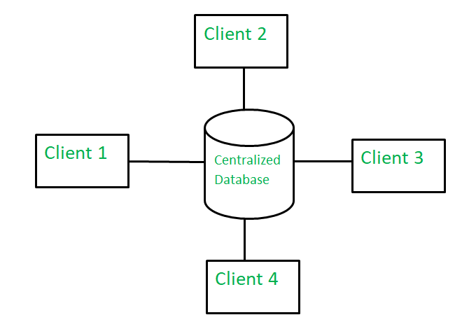

Advantages
- Since all data is stored at a single location only thus it is easier to access and coordinate data.
- The centralized database has very minimal data redundancy since all data is stored in a single place.
- It is cheaper in comparison to all other databases available.

Disadvantages
- The data traffic in the case of a centralized database is more.
- If any kind of system failure occurs in the centralized system then the entire data will be destroyed.

What is a Distributed Database?
A distributed database is basically a type of database which consists of multiple databases that are connected with each other and are spread across different physical locations. The data that is stored in various physical locations can thus be managed independently of other physical locations. The communication between databases at different physical locations is thus done by a computer network.

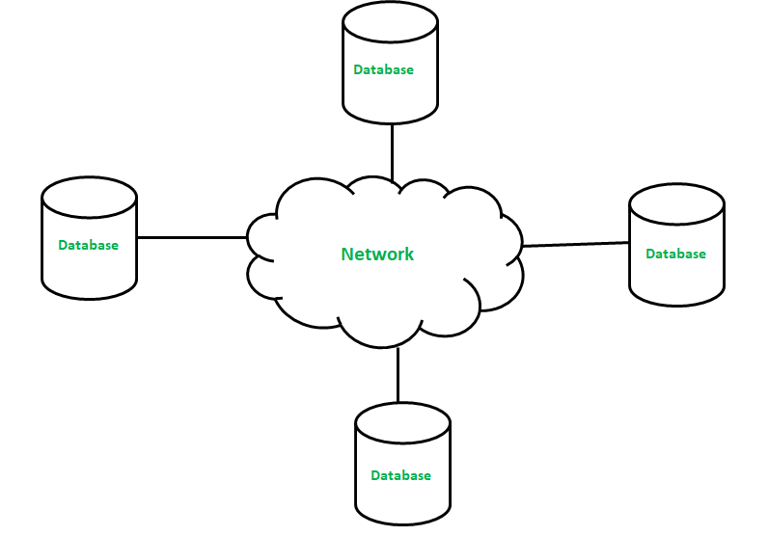Advantages
- This database can be easily expanded as data is already spread across different physical locations.
- The distributed database can easily be accessed from different networks.
- This database is more secure in comparison to a centralized database.

Disadvantages
- This database is very costly and is difficult to maintain because of its complexity.
- In this database, it is difficult to provide a uniform view to users since it is spread across different physical locations.

Difference Between Centralized database and Distributed Database

Basis of Comparison | Centralized database | Distributed database
Definition | It is a database that is stored, located as well as maintained at a single location only. | It is a database that consists of multiple databases which are connected with each other and are spread across different physical locations.
Access time | The data access time in the case of multiple users is more in a centralized database. | The data access time in the case of multiple users is less in a distributed database.
Management of Data | The management, modification, and backup of this database are easier as the entire data is present at the same location. | The management, modification, and backup of this database are very difficult as it is spread across different physical locations.
View | This database provides a uniform and complete view to the user. | Since it is spread across different locations thus it is difficult to provide a uniform view to the user.
Data Consistency | This database has more data consistency in comparison to distributed database. | This database may have some data replications thus data consistency is less.
Failure | The users cannot access the database in case of database failure occurs. | In a distributed database, if one database fails users have access to other databases.
Cost | A centralized database is less costly. | This database is very expensive.
Maintenance | Ease of maintenance because the whole of the data and information is available at a single location and thus, easy to reach and access. | It is difficult to maintain because of the distribution of data and information at varied places. So, there is a need to check for data redundancy issues and how to maintain data consistency.
Efficient | A centralized database is less efficient as data finding becomes quite complex because of the storing of data and information at a particular place. | A distributed database is more efficient than a centralized database because of the splitting up of data at several places which makes data finding simple and less time-consuming.
Response Speed | The response speed is more in comparison to a distributed database. | The response speed is less in comparison to a centralized database.
Advantages | - Integrity of data  - Security  - Easy access to all information  - Data is easily portable | - High performance because of the division of workload.  - High availability because of the readiness of available nodes to do work.  - Independent nodes and better control over resources
Disadvantages | - Data searching takes time  - In case of failure of a centralized server, the whole database will be lost.  - If multiple users try to access the data at the same time then it may create issues. | - It is quite large and complex so difficult to use and maintain.  - Difficult to provide security  - Issue of data integrity  - Increase in storage and infrastructure requirements  - Handling failures is a quite difficult task
Examples | - A desktop or server CPU  - A mainframe computer. | - Apache Ignite  - Apache Cassandra  - Apache HBase  - Amazon SimpleDB  - Clusterpoint  - FoundationDB.

Difference between Parallel and Distributed databases

Parallel and Distributed Databases are significant components within an enormous quantity of big data processing since they help to enhance data handling in terms of efficiency and expandability. Nonetheless, there is sometimes confusion between them because both are aimed at achieving the most effective solution to the organization’s handling of its data. This article lays out the definition of parallel and distributed databases, their functionality, and pros and cons to give you an insight into what system is more desirable for use in certain cases.

What is Parallel Database?

A parallel DBMS is a DBMS that runs across multiple processors and is designed to execute operations in parallel, whenever possible. The parallel DBMS links several smaller machines to achieve the same throughput as expected from a single large machine.

Features
- There are parallel working of CPUs
- It improves performance
- It divides large tasks into various other tasks
- Completes work very quickly

Advantages of Parallel Databases
- Increased Speed and Efficiency: That is why the application of parallel databases allows executing several queries at the same time and consequently, decreases the total amount of time needed for processing them.
- Improved Resource Utilization: Most of them take advantage of the multi-processor architecture, thus using as many CPU cores as possible.
- High Throughput: They perform a large number of computations in less time more than the sequential methods hence suitable for large-scale uses.

Disadvantages of Parallel Databases
- Complexity in Maintenance: Indeed, employment of parallel databases might be slightly problematic as synchronization and some other components of the processes are worthy of special attention.
- Higher Costs: While parallel databases may be defined with robust physical databases which require intensive hardware the databases may be more costly in setting up and even in operation.

What is Distributed Database?

A Distributed database is defined as a logically related collection of data that is shared which is physically distributed over a computer network on different sites. The Distributed DBMS is defined as, the software that allows for the management of the distributed database and makes the distributed data available for the users.
Features
- It is a group of logically related shared data
- The data gets split into various fragments
- There may be a replication of fragments
- The sites are linked by a communication network
The main difference between the parallel and distributed databases is that the former is tightly coupled and then later loosely coupled.

Advantages of Distributed Databases
- Fault Tolerance: Since the data is distributed to various centers, failure in one center does not result to the total failure of the system.
- Scalability: Due to the ability of distributed databases, it can easily be scaled up by adding nodes to the network which makes it ideal for businesses that are expanding.
- Local Autonomy: Every site can administer a separate data base, however they are all in the collective database at the same time.

Disadvantages of Distributed Databases

- Complex Data Management: Sharing data with multiple facilities presents some problems like latency of data.
- Security Concerns: The more the places there is data stored the higher the risk of breaches hence the need to enforce very strict security measures.

Difference Between Parallel and Distributed Databases

Parallel Database | Distributed Database
In parallel databases, processes are tightly coupled and constitutes a single database system i.e., the parallel database is a centralized database and data reside in a single location | In distributed databases, the sites are loosely coupled and share no physical components i.e., distributed database is our geographically departed, and data are distributed at several locations.
In parallel databases, query processing and transaction is complicated. | In distributed databases, query processing and transaction is more complicated.
In parallel databases, it’s not applicable. | In distributed databases, a local and global transaction can be transformed into distributed database systems
In parallel databases, the data is partitioned among various disks so that it can be retrieved faster. | In distributed databases, each site preserve a local database system for faster processing due to the slow interconnection between sites
In parallel databases, there are 3 types of architecture: shared memory, shared disk, and shared shared-nothing. | Distributed databases are generally a kind of shared-nothing architecture
In parallel databases, query optimization is more complicated. | In distributed databases, query Optimisation techniques may be different at different sites and are easy to maintain
In parallel databases, data is generally not copied. | In distributed databases, data is replicated at any number of sites to improve the performance of systems
Parallel databases are generally homogeneous in nature | Distributed databases may be homogeneous or heterogeneous in nature.
Skew is the major issue with the increasing degree of parallelism in parallel databases. | Blocking due to site failure and transparency are the major issues in distributed databases.

Difference Between Client /Server and Distributed DBMS

In today’s digital era, managing large volumes of data efficiently and effectively is very crucial for any organization. Here we have the requirement of a Database and to manage it we also require a management system. Two most popular database management systems are Client/Server DBMS and Distributed DBMS. Both aim to facilitate data storage, data accessibility, and how we manage the data effectively.
A Client/ Server DBMS is a more centralized DBMS system, where all the data is stored on a single server, and the client requests to server to fetch certain information. On the other hand, Distributed DBMS splits all the data across the multiple server, in various different locations to improve accessibility speed.

What is DBMS ( Database Management System )?
DBMS is basically a management system that is used to manage data in the Database. It allows various operations to be performed on the Database with the use of Data Manipulation Language and Data Definition Language. It allows users to store data, manage the data in DB more efficiently by performing CRUD Operation (Create, Read, Update, Delete).
In this article, we’ll deep dive into two more popular types of DBMS architectures:
- Client/Server DBMS
- Distributed DBMS

What is Client / Server DBMS?
In a Client / Server architecture , the database is centralized located on the server and clients (users or application) request for certain data from it.
Client/server is developed to deal with various computing environments that have a large number of computers and servers connected together via a network. In this architecture, a Client is a user machine which provides the user interface and local processing capabilities. When any client requires additional functionality like database access, it can connect to Server that is capable of providing the functionality needed by the client. Basically Server is a machine that provides services to the Client i.e user machine.

Advantages of Client / Server DBMS
- Data is Centralized : It is easier to manage and secure these types of DBMS since all the data is stored at one place .
- Simple in Design : Client/Server DBMS are simple in design , the users are directly connected to data base layer , there is no layer of abstraction.
- Simple Backup and Recovery : Since everything in these DBMS system is stored at one server , so backups are more easier and straightforward.
- Upgradation/Replacement is Easier : It facilitate to upgrade and replacement easily due to its centralized structure.
- Consistent Performance : Till the server bear the request easily , its performance remains consistent.

Disadvantages of Client / Server DBMS
- Continuous Maintenance : Client/Server models needs to be continuously monitored , since any fault in the server leads to failure in the whole network.
- Security Related Issues : Since it is simple in design , this leads to increase the risk of breach in the security parameter.
- Scalability related issues : They are not much suitable to handle the large clients , the server may be overloaded.
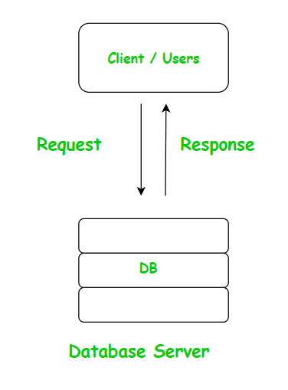
Client / Server DBMS Model

What is Distributed DBMS?

Unlike the client/server model , a Distributed DBMS distributes its data across the multiple server ( or nodes ) and they are interconnected with themselves. Moreover, as a result multiple server are located around the world and they work well in co-ordination with each other.
In Distributed DBMS, data is distributed over the geographical site. Each site is a complete database system site on its end but the different sites have to work together because if any user wants to access the data it can easily access data anywhere in the network as the data is stored at the user’s own computer.
For example :- Think of a very large library , where the different types of books are stored in different section / block of the library. The main objective is to allocate the books categories based on content , this increase the easiness to the person to get the required book even if the other section of library is busy.

Advantages of Distributed DBMS
- Failure Tolerance : If any one of the server is down , the rest of the system can still function well .
- Scalability : Due to increase in the number of clients , more servers are easily added to the existing system, without overloading on the single server.
- Efficient in Performance : Since they are distributed , so we fetch the data from the nearest data center that will enhance the access time.

Disadvantages of Distributed DBMS
- Complex in Design : Managing and co-ordinating between multiple server across the globe , is very complex and challenging as well.
- Data Inconsistency : Since they are located across the globe , so all the server may not get the updated data at the same time , due to some latency , this causes the data inconsistency problem.
- Cost : Since multiple server are going on continuously , so they require more resources and cost.

Can we switch from a Client/Server DBMS model to a Distributed DBMS model ?

Yes, but it requires a lot of planning. Converting the centralized DBMS into a Distributed require certain type of infrastructural changes in-order to attain the proper synchronization , consistency between the distributed servers.

Difference between Parallel and Distributed databases

Parallel and Distributed Databases are significant components within an enormous quantity of big data processing since they help to enhance data handling in terms of efficiency and expandability. Nonetheless, there is sometimes confusion between them because both are aimed at achieving the most effective solution to the organization’s handling of its data. This article lays out the definition of parallel and distributed databases, their functionality, and pros and cons to give you an insight into what system is more desirable for use in certain cases.

What is Parallel Database?
A parallel DBMS is a DBMS that runs across multiple processors and is designed to execute operations in parallel, whenever possible. The parallel DBMS links several smaller machines to achieve the same throughput as expected from a single large machine.

Features
- There are parallel working of CPUs
- It improves performance
- It divides large tasks into various other tasks
- Completes work very quickly

Advantages of Parallel Databases
- Increased Speed and Efficiency: That is why the application of parallel databases allows executing several queries at the same time and consequently, decreases the total amount of time needed for processing them.
- Improved Resource Utilization: Most of them take advantage of the multi-processor architecture, thus using as many CPU cores as possible.
- High Throughput: They perform a large number of computations in less time more than the sequential methods hence suitable for large-scale uses.

Disadvantages of Parallel Databases
- Complexity in Maintenance: Indeed, employment of parallel databases might be slightly problematic as synchronization and some other components of the processes are worthy of special attention.
- Higher Costs: While parallel databases may be defined with robust physical databases which require intensive hardware the databases may be more costly in setting up and even in operation.

What is Distributed Database?
A Distributed database is defined as a logically related collection of data that is shared which is physically distributed over a computer network on different sites. The Distributed DBMS is defined as, the software that allows for the management of the distributed database and makes the distributed data available for the users.
Features
- It is a group of logically related shared data
- The data gets split into various fragments
- There may be a replication of fragments
- The sites are linked by a communication network
The main difference between the parallel and distributed databases is that the former is tightly coupled and then later loosely coupled.

Advantages of Distributed Databases
- Fault Tolerance: Since the data is distributed to various centers, failure in one center does not result to the total failure of the system.
- Scalability: Due to the ability of distributed databases, it can easily be scaled up by adding nodes to the network which makes it ideal for businesses that are expanding.
- Local Autonomy: Every site can administer a separate data base, however they are all in the collective database at the same time.

Disadvantages of Distributed Databases
- Complex Data Management: Sharing data with multiple facilities presents some problems like latency of data.
- Security Concerns: The more the places there is data stored the higher the risk of breaches hence the need to enforce very strict security measures.

Difference Between Parallel and Distributed Databases

Parallel Database | Distributed Database
In parallel databases, processes are tightly coupled and constitutes a single database system i.e., the parallel database is a centralized database and data reside in a single location | In distributed databases, the sites are loosely coupled and share no physical components i.e., distributed database is our geographically departed, and data are distributed at several locations.
In parallel databases, query processing and transaction is complicated. | In distributed databases, query processing and transaction is more complicated.
In parallel databases, it’s not applicable. | In distributed databases, a local and global transaction can be transformed into distributed database systems
In parallel databases, the data is partitioned among various disks so that it can be retrieved faster. | In distributed databases, each site preserve a local database system for faster processing due to the slow interconnection between sites
In parallel databases, there are 3 types of architecture: shared memory, shared disk, and shared shared-nothing. | Distributed databases are generally a kind of shared-nothing architecture
In parallel databases, query optimization is more complicated. | In distributed databases, query Optimisation techniques may be different at different sites and are easy to maintain
In parallel databases, data is generally not copied. | In distributed databases, data is replicated at any number of sites to improve the performance of systems
Parallel databases are generally homogeneous in nature | Distributed databases may be homogeneous or heterogeneous in nature.
Skew is the major issue with the increasing degree of parallelism in parallel databases. | Blocking due to site failure and transparency are the major issues in distributed databases.

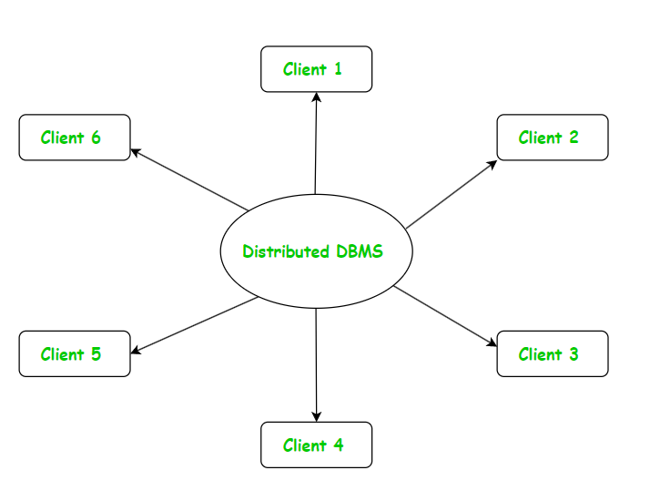
Distributed DBMS

Difference Between Client/Server and Distributed DBMS

Properties | Client/Server DBMS | Distributed DBMS
Architecture | Centralized server | Multiple Server (distributed across globe)
Fault Tolerance | Low fault tolerance | High fault tolerance
Scalability | Limited scalability | Easy to Scalable
Design | Simple in Design | Complex in design
Security | Less Secure due to its , simple Designing | More Security due to its complex designing.
Accessibility | Client can access only one server at a time. | User can access many sites simultaneously.
Data Storage | Data is stored on central server. | Data is stored across multiple serve , often in different geographical location as well.
Data Access Speed | Speed of accessing database is poor as compared to Distributed DBMS. | Speed of accessing database is much better than Client/Server Architecture.
Data Availability | If somehow server crashes, the whole system stops. | The crash of one site does not stop the entire system.
Cost | It is less expensive as compared to Distributed DBMS. | It is more expensive.
Maintenance | Maintenance cost is low. | Maintenance cost is high.

